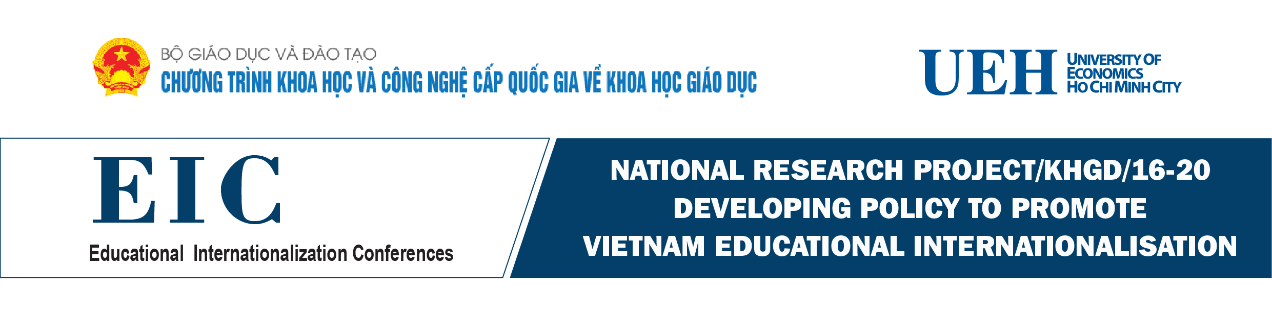

PROGRAMME
Date and Time: 8:00 - 12:30 on Friday 9th November 2018
Conference Hall: A.205 – University of Economics Ho Chi Minh City

Time (hrs.) | Programme | Speakers/Chairs/Panelists
8:00 - 8:10 | Registration  UEH Reception | Dr. Tran Mai Dong  Head of Research Management and International Cooperation Department
8:00 - 8:30 | Cultural Music and Show Welcome & Photo Session  UEH Reception
8:30 - 8:35  A205 | Introductory Remarks | Dr. Tran Mai Dong  Head of Research Management and International Cooperation Department
8:35 - 8:40 | Welcome Remarks | Prof. Dr. Nguyen Trong Hoai  Vice President - UEH
8:40 - 8:45 | Opening Remarks | Assoc. Prof. Dr. Pham Quang Hung  General Director- Vietnam International Education Cooperation Department (VIED) - MOET
8:45 - 10:30 | Panel Discussion 1: “Policies to promote Internationalisation of Education” | Chair: Prof. Dr. Nguyen Trong Hoai  Vice President - UEH
8:45 - 9:00 | Internationalisation of Higher Education: The case of JGU Mainz | Professor Dr. Mechthild Dreyer  Former Vice President of Learning and Teaching  Johannes Gutenberg-University Mainz
9:00 - 9:15 | Internationalization of Higher Education in the Industrial revolution 4.0: Case in Thailand with a Specific Strategy at Chiang Mai University | Dr. Charin Techapun  Vice President Chiang Mai University
9:15 - 9:30 | Best practice: Promoting the strategic partnership between WSU-UEH | Prof. Yi-Chen Lan  Pro Vice - Chancellor Global Development  Western Sydney University
9:30 - 9:45 | Internationalization of Higher Education: Best practice of Vietnamese-German University | Dr. Ha Thuc Vien  Vietnamese-German University (VGU)
9:45 - 10:00 | Internationalization in Vietnamese Universities: Perspectives and Practicalities | Prof. Dr. Nguyen Trong Hoai  Vice President – UEH  and UEH research group
10:00 - 10:30 | Panel Discussion | Chair: Prof. Dr. Nguyen Trong Hoai  Keynote Speakers & All Participants
10:30 - 10:45 | Coffee break
10:45 - 12:30 | Panel Discussion 2: “Best Practice & Policies to promote Internationalisation of Education” | Chair: Dr. Ha Thuc Vien  Acting President  Vietnamese-German University (VGU)
10:45 - 11:00 | The Reality of Internationalisation of Education in Japan | Prof. Akinori Seki  Faculty of Contemporary Law, and General Education Center  Tokyo Keizai University
11:00 - 11:15 | Internationalisation of Education & Skills and Competencies for the 21st century | Dr. Nguyen Thi Thanh Phuong  Country Director - Arizona State University  Dr. Ly Thi Minh Chau – UEH
11:15 - 11:30 | Auditing as Means to Promote Internationalization | Mr. Frank Niedermeier  Dept. for Higher Education Studies - Centre for Quality Development  University of Potsdam
11:30 - 11:45 | Policies to promote academic exchange and research | Prof. Dr. Uwe Schmidt  Director of Center for Quality Assurance and Development (ZQ)  Johannes Gutenberg-University Mainz
11:45 - 12:00 | Internationalization of Teacher Training at University of Potsdam | Prof. Dr. Andreas Borowski  Director of Teacher Education and Education Research Centre (ZeLB)  University of Potsdam
12:00 - 12:30 | Panel Discussion & Concluding Remarks | Chair: Dr. Ha Thuc Vien  Keynote Speakers & All participants
12:30 – 13:30 | Lunch | at UEH

